Simple Electric Circuit with Switch

Description:
This project shows how a basic electric circuit works. By using a switch, students can turn an LED ON and OFF, just like controlling a light bulb at home.
Block Diagram:
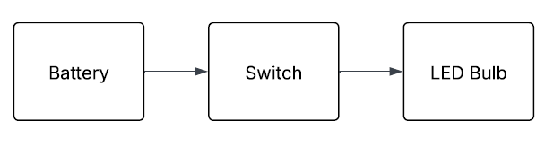
Pinout / Circuit Connection:
- LED (Light Emitting Diode) – for output
- Switch / Push Button – to control the LED
- Battery (9V or AA battery pack) – as power source

Components Required:
- Switch one terminal → Battery Positive (+)
- Switch other terminal → Resistor → LED Anode (+)
- LED Cathode (–) → Battery Negative (–)

Working Principle:
The project works on the principle of a closed and open circuit.
- When the switch is pressed → circuit is closed → current flows → LED turns ON.
- When the switch is released → circuit is open → no current → LED turns OFF.

Operation (Step-by-Step):
- Connect the battery, LED, resistor, and switch as per the circuit.
- Keep the switch in the OFF position → LED stays OFF.
- Press the switch → current flows → LED glows.
- Release the switch → current stops → LED goes OFF.

Conclusion: (Predefined/self-written)
This project helps students understand the fundamentals of electricity – how a switch controls the flow of current. It is a foundation for all electronic projects, from simple lamps to smart devices.

For Your References:
[1] Arduino, “Digital Read Function,” Arduino.cc. [Online]. Available: https://www.arduino.cc/reference/en/language/functions/digital-io/digitalread/. [Accessed: 27-Aug-2025].
[2] All About Circuits, “Understanding LED Circuits,” Allaboutcircuits.com, 2022. [Online]. Available: https://www.allaboutcircuits.com/projects/introduction-to-leds/. [Accessed: 27-Aug-2025].

